1. a. Formulate minmax problem into min z s.t. z>=2x1-x2 and z>=-3x1+2x2 and 3x1+x2<=5 , where z is free. Bring into standard form by substituting z with z+ z-. Add excesses and slack. Check if all-slack basis is feasible, it is. So no two-phase simplex requiredaaaaaaaaaaaaaaaaaaaaaaaaaaaaaaaaaaaaaaaaaaaaaaaaaaaaaaaaaaaaaaaaaaaaaaaaaaaaaaaaaaaaaaaaaaaaaaaaaaaaaaaaaaaaaaaaaaaaaaaaaaaaaaaaaaaaaaaaaaaaaaaaaaaaaaaaaaaaaaaaaaaaaaaaaaaaaaaaaaaaaaaaaaa . 1234567890 Formulate tableau, all the pivots are degenerate. Do 3? Pivots before you notice cycling. Infinite solutions exist for the optimal value z=0 (due to the z+ - z- combo). One such is (x1,x2,x3,x4,x5,z+,z-) = (0,0,0,0,5,0,0).

I don’t think Bland’s rule changes anything, I only got 1 variable with a positive cost in each tableau (not sure tho). Moreover, since there exist infinite optimal solutions, and Bland’s rule if applied guarantees no cycling, I don’t know if it can be applied.

b. Check slides

c. I think Giuliano said on Piazza there’s a typo and they gave the original z in the exam room, otherwise this is impossible.

|  |  |  |  |  |  |  |
| --- | --- | --- | --- | --- | --- | --- |
| BV | x1 | x2 | x3 | x4 | xi1 | RHS |
| z | 0 | 0 | (needs to be given) | (needs to be given) | 0 | (needs to be given) |
| x2 | 0 | 1 | -2 | -1 | 2 | 3 |
| x1 | 1 | 0 | 1 | 1 | -1 | 0 |
| xi1 | 0 | 0 | 1 | 0 | -1 | 0 |

d. From case study 4 on wines.

2a) min 500x1 + 600x2 + 700x3 + 700x4 + 700x5 + 700x6 + 600x7

(where ‘xi’ represents the number of people that start on day ‘i’)

St.

x1+ x4 + x5 + x6 + x7 >= 17

x1+ x2 + x5 + x6 + x7 >= 13

x1+ x2 + x3 + x6 + x7 >= 15

x1+ x2 + x3 + x4 + x7 >= 19

x1+ x2 + x3 + x4 + x5 >= 14

x2+ x3 + x4 + x5 + x6 >= 16

x3 + x4 + x5 + x6 + x7 >= 11

x1, x2, x3, x4, x5, x6, x7 non-negative integers

An alternative solution:

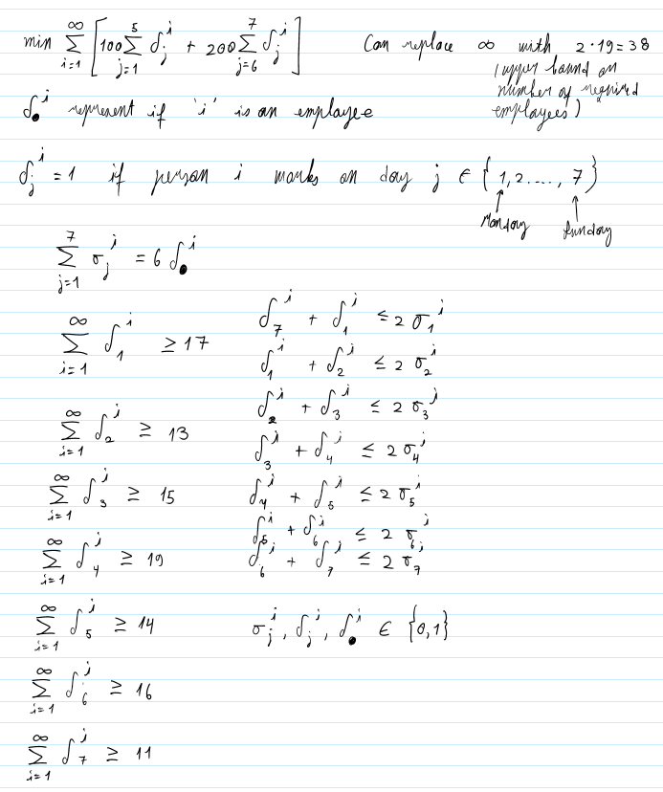

(Note that taking 2 consecutive days off is equivalent to working on 5 consecutive days; also, this formulation allows us to change our objective to sum all of the delta_.^i which would mean minimising the number of employees, whereas the one above would have a difficult time being reformulated into something which minimises the number of employees)

2b)

I) just a regular min-max formulation like in coursework of 2021-2022

Ii) ???

Iii) no Nash equilibrium – the minima of all the rows is –1, the maxima of all the columns is +1. The maximum of the minima != the minimum of the maxima => no Nash equilibrium.

3a) I) min y

s.t. y >= c

-y >= -4

Y >= 0

Ii) y * = 2. z*(LP) = 2. x* = (1,0)

Iii) When c <= 4, dual LP has a feasible solution.

There is always a feasible solution for primal LP no matter how the value of c changes.

B

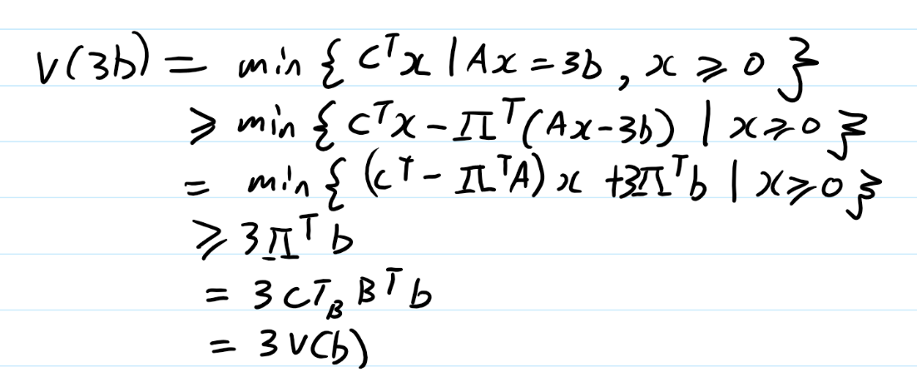[1]

4.a. All are valid? Not sure for the definition, maybe integer coefs.

I.) Not useful, excludes integral solution at y1=5, so not a useful cut.

Ii) Cuts the feasible set without excluding integer solutions, so useful, IF objective function was such that the left vertex in the feasible region was the optimal vertex for the relaxed problem.

Iii) Useful for the original feasible set since y1 max = 6 y2 max = 4, but from figure this lies outside the existing feasible set, so not useful.

b. Strategy: use delta1, delta2, delta3 to signal we are in one of the shapes, e.g. delta1 = 1 means we are in shape 1 (the rectangle).

Constraints on x1:

1 – x1 <=0

X1 – 2 - (1-delta1) M <= 0

X1 – 2 - (1-delta2) M <= 0

3- X1 - (1 – delta3) M <= 0

X1 – 4 <= 0

Constraints on x2:

-X2 <= 0

X2 – 0.5 - (1-delta1) M <= 0

1.5 - x2 - (1-delta2) M <= 0

Mixed:

X2 – 2x1 + 1.5 - (1-delta2) M <= 0

-5x1 – 2x2 +20 - (1-delta3) M <= 0

-x1 + 2x2 –2 - (1-delta3) M <= 0

Logical:

Delta1 + delta 2 + delta3 = 1

Deltai in {0,1} for all i in {1,2,3}

c. Solve relaxed initial prob graphically, x* = (2.25, 8) OPT = infinity

Check graph, obv it’s better to branch on x1.

Left side (P1) : added constraint x1<=2.

Right side (P2): added constraint x1>=3

Solve P1 graphically, x* = (2, 8) z* = 160. Integral so stop, also set OPT = 160

Solve P2 graphically, x* = (3, 6.5) z* = 157.5. 157.5 < 160 so can’t improve, STOP.

End of BnB, x*=(2,8) with z* = 160

Check tutorial 7 ex. 3 for the correct layout to get full mark





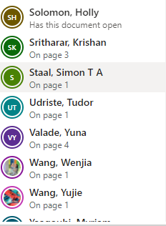

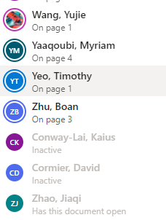

My job offer got rescinded because of this module. We’ll be in touch in due course.

Fuck muse

1. authentiques